**Assignment 1**

**Installation DVWA In Windows 10 Using XAMPP**

Damn Vulnerable Web Application (DVWA) is a PHP/MySQL web application that is damn vulnerable. Its main goal is to be an aid for security professionals to test their skills and tools in a legal environment, help web developers better understand the processes of securing web applications, and to aid both students & teachers to learn about web application security in a controlled classroom environment.

The aim of DVWA is to practice some of the most common web vulnerabilities, with various levels of difficulty, with a simple straightforward interface. Please note, there are both documented and undocumented vulnerabilities with this software. This is intentional. You are encouraged to try and discover as many issues as possible.

**1) Download DVWA >** <http://www.dvwa.co.uk/>

**Download and install XAMPP on your computer**

XAMPP is a free and open-source cross-platform web server solution stack package developed by Apache Friends, consisting mainly of the Apache HTTP Server, MariaDB database, and interpreters for scripts written in the PHP and Perl programming languages

**Download Link >** <https://www.apachefriends.org/download.html>

**2) Open XAMPP and start ‘Apache and MySQL’**

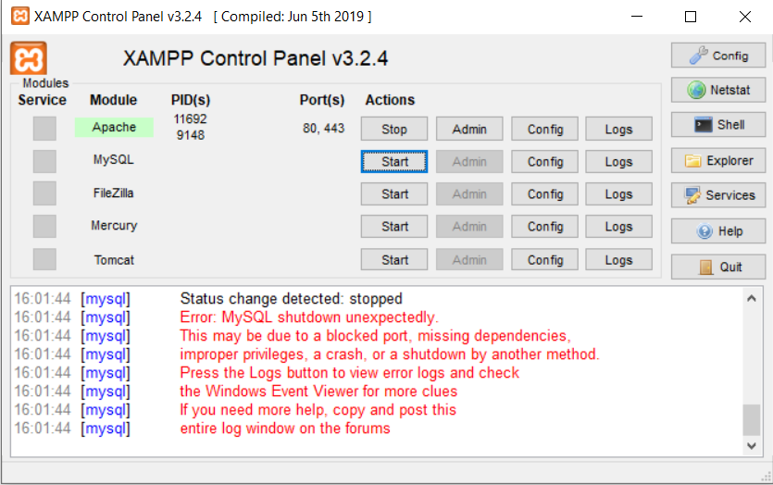

**3)** After downloading dvwa files compressed and move the file to the htdocs folder of the xampp application.

**4)** Then **A filename ‘config.inc.php.dist ‘ rename it to ‘config.inc.php’ available in htdocs\dvwa\config**

**5)** **Now, type ‘127.0.0.1/dvwa’ in the URL of the browser**

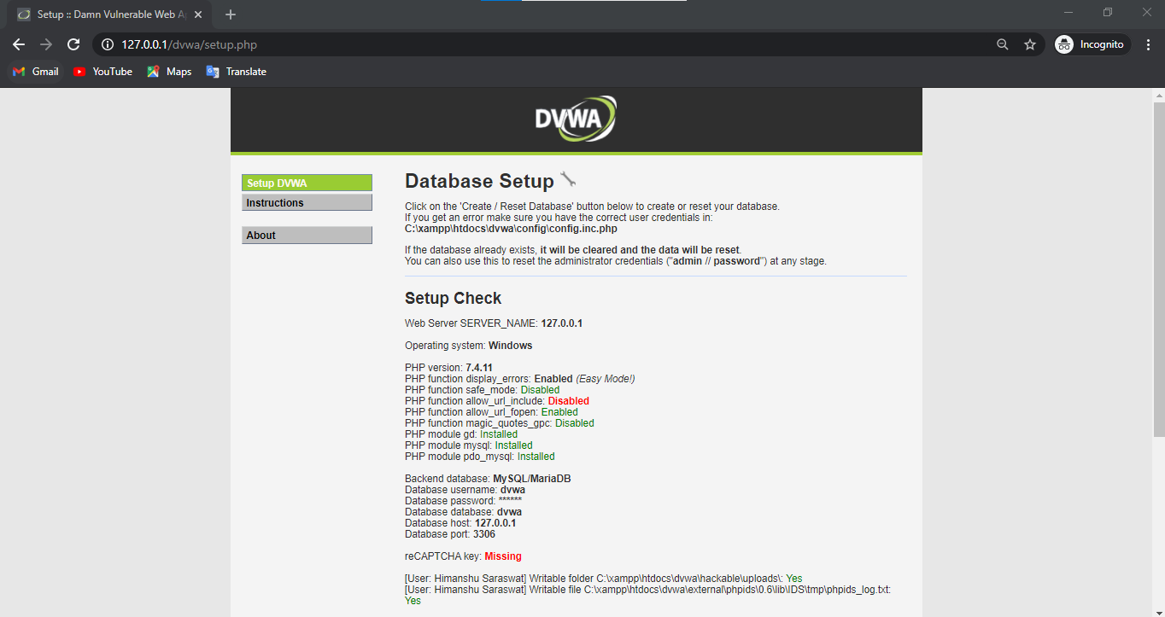

**6)** **Now, we need to edit the config file that we rename in the earlier step.**

Then open it in Notepad and in the password tab , clear the password or make the password empty by remove the default password and give username as root.

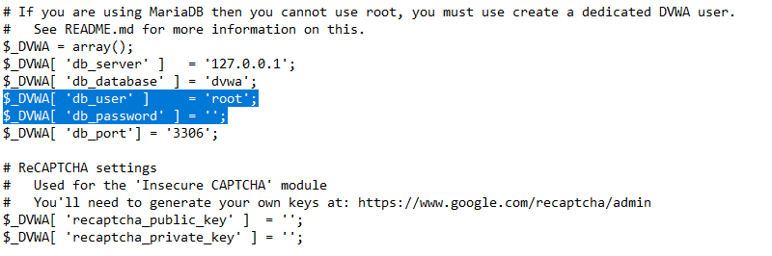

**7)** Then **click on ‘Create / Reset Database’**

**You will see this type of output.**

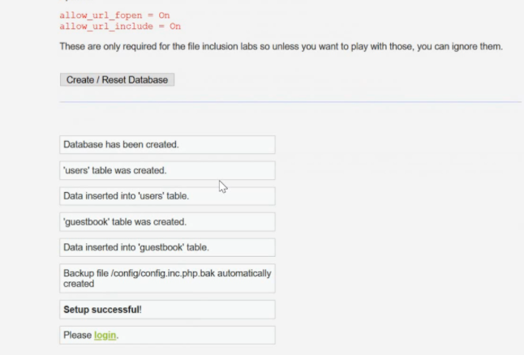

**8)** **Click on ‘Login’ or it will automatically redirect to the login page.**

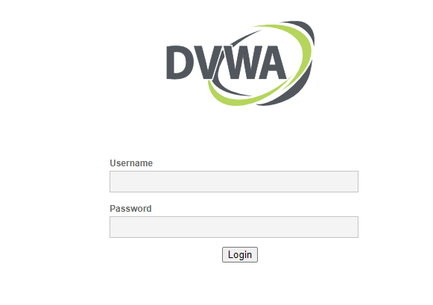

**The default username is ‘admin’ and the password is ‘password’.**

**9) Then you would see the homepage of dvwa application and finally installed.**

